Erasmus + “MIGRANT Biographies” – Europe on move
Project Code: 2018-1-AT01-KA229-047536_3

Multicultural and Intercultural Questionnaire – Fact-finding Survey
GENERAL Information
Born o: (or presumable age: ) Sex: Origin:
Italian citizen: YES /NO In Italy since:
Mother’s citizenship: In Italy since:
Father’s citizenship: In Italy since:
Answer the first questions briefly and in more detail the last question
- Are you familiar with the term “multiculture”?
- Yes; - No.
- Find the best defining option among these:
- Responsibility to integrate foreigner;
- Obligation for foreigner;
- Society with different separated cultures.

- Match a word given or suggest another one to the picture:
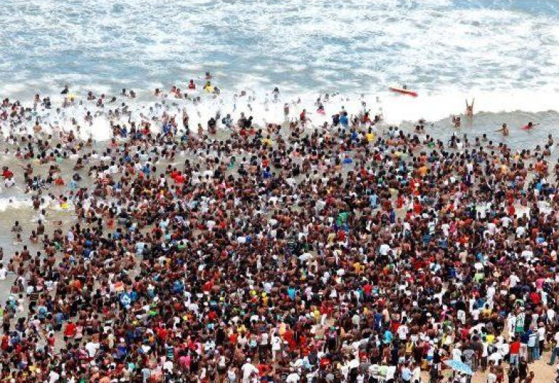
A) fear;
B) prevention;
C) confusion;
D) danger;
E) planning;
F) problem;
G) other: _______________

- What is according to you the most intercultural school subject in your school?

- History; - Art; - Maths; – Information Computer Technology; - Citizenship;
- Physical Education; - Foreign Language - Science; - Religion;
- Other (specify)__________

- What is instead, the least intercultural subject?

- History; - Art; - Maths; – Information Computer Technology; - Citizenship;
- Physical Education; - Foreign Language - Science; - Religion;
- Other (specify)__________

- What aspect makes you more curious about different cultures than yours?

- ICT tools; - Music; - Food; - Religion; - Political system;
- Fashion; - gender role; - Other(specify): _________________

- Which aspect, instead, of your culture do you think should be widespread?

- ICT tools; - Music; - Food; - Religion; - Political system;
- Fashion; -gender role; - Other(specify): _________________

- According to you, could a school subject be presented in the school curriculum with the purpose of teaching inclusion and integration? If yes, what name or program would you suggest?

- Yes; - No;

- In what aspect do you think mediation should mostly act between two cultures?

- linguistic, - religious, - food, - ideological, - way of life,
- other _____________________

- Are you happy living here? - Yes; - No; - I don’t know.

- Choose the best definition of multicultural society:

- Integration without loosing one’s own identity;
- Being integrated into a foreign society;
- Adopting the values of the hosty country.

